SIMATS ENGINEERING (SAVEETHA SCHOOL OF ENGINEERING)

Department of Artificial Intelligence and Data Science
ASSESSMENT TOOL 2 – Case Study

Course Code: | DSA03 | Course Title: | Natural Language Processing
CO Assessed: | CO3 – Precision | Assessment: | Assessment Tool 2 – Case Study
Weightage: | 30% of CIA
CO5 Statement: | Apply N-gram models, smoothing techniques, part-of-speech tagging systems and to evaluate effective syntactic analysis. (BL-3)
Student Name: | M Jeevitha | Reg. No.: | 192424257
Section / Batch: | 2024-C | Date: | 15-8-2026
Code of Conduct
I M Jeevitha(192424257) (Name / Reg No) certify that this submission is my original work and that I have adhered to the guidelines specified for this assessment. I understand that any violation of academic integrity rules will result in disciplinary action.
Signature of the Student: Jeevitha
Instructions
- Read all three case studies carefully before attempting the questions.
- Provide appropriate justifications and interpretations for every computed result.
- Use NLP concepts, algorithms, and terminology wherever applicable.
- Diagrams, flowcharts, tables, or mathematical formulations may be used to support your answers.
- Duration: 30 minutes.

Section / Topic | Focus | Case Study
N-Gram Language Models and Smoothing Techniques | Bigram and Trigram probability computation, Maximum Likelihood Estimation (MLE), Backoff models, Deleted Interpolation, Entropy calculation, uncertainty analysis, real-time next-word prediction | Case Study 1 – Smart Mobile Keyboard Prediction System
Part-of-Speech (POS) Tagging and Word Classes | Penn Treebank tagset, contextual ambiguity resolution, rule-based tagging, stochastic tagging (HMM), emission and transition probabilities, word class identification, chatbot language understanding | Case Study 2 – AI-Powered Customer Support Chatbot
Transformation-Based Tagging (Brill Tagger) | POS tag correction, transformation rules, contextual tagging, linguistic validation, tag sequence refinement, ambiguity handling | Case Study 3 – News Analytics and POS Tag Correction System
Corpus Statistics and Probabilistic Analysis | Word frequency counting, corpus-based probability estimation, entropy-based uncertainty measurement, tagging confidence evaluation | Case Study 3 – News Analytics and POS Tag Correction System
Integrated Syntactic Analysis and NLP Applications | Application of language models, POS tagging, probabilistic methods, corpus analysis, ambiguity resolution, and decision-making in real-world NLP systems | Case Studies 1, 2, and 3

Annexure A – Case Study

CASE STUDY 1: E-Commerce Smart Search and Product Prediction System

An e-commerce company is developing an AI-powered search and autocomplete system that predicts the next word when customers enter product-related queries. The language model is trained on the corpus:

"machine learning improves business, machine learning enables automation, machine learning drives innovation."

The development team uses Bigram and Trigram Language Models, Backoff Models, Deleted Interpolation, and Entropy Analysis to improve search prediction and handle unseen word sequences.

The following statistics are obtained from the corpus:

- C(machine) = 3
- C(machine learning) = 3
- C(learning improves) = 1
- C(learning enables) = 1
- C(learning drives) = 1
- C(learning improves business) = 1 The interpolation weights are:
- λ₁ = 0.5 (Trigram)
- λ₂ = 0.3 (Bigram)
- λ₃ = 0.2 (Unigram)

The prediction probabilities after the word "learning" are:

- P(improves) = 0.33
- P(enables) = 0.33
- P(drives) = 0.33

Questions

- Compute the Maximum Likelihood Estimate (MLE) of the Bigram Probability P(learning | machine). Interpret how this probability can influence the next-word prediction of an e-commerce search system.
- A customer enters the unseen sequence "machine learning transforms". Apply the Backoff Model and estimate the probability of the word "transforms" using lower-order N-grams. Explain why backoff is useful when customers enter previously unseen search queries.
- Using Deleted Interpolation, calculate the probability of the sequence "machine learning improves" using the given interpolation weights. Explain how combining trigram, bigram, and unigram probabilities improves robustness when training data is sparse.
- Calculate the Entropy of the prediction distribution P(improves) = 0.33, P(enables) = 0.33, P(drives) = 0.33. Interpret the entropy value and explain what it indicates about uncertainty in the search prediction system.

- Develop a Python program using NLTK for N-gram generation, NumPy for probability computations, and the Math library for entropy calculation. The program should construct Unigram, Bigram, and Trigram models from the given corpus, compute the MLE Bigram probability, estimate an unseen sequence using Backoff, calculate the Deleted Interpolation probability using the given weights, compute entropy of the prediction distribution, and display all intermediate calculations and the final next-word prediction in a structured format.

CASE STUDY 2: AI-Powered Hospital Appointment Chatbot

A healthcare organization develops an AI-powered chatbot that assists patients in booking appointments. The chatbot performs Part-of-Speech tagging before identifying user intentions and generating responses.

Consider the following user inputs:

"Book an appointment with the doctor."
- "The book contains medical information."

The chatbot uses the Penn Treebank POS Tagset and an HMM-based probabilistic POS tagger to determine the grammatical role of ambiguous words.

For the word "book", the system is given:

  - P(book | VB) = 0.7
  - P(book | NN) = 0.3
  - P(Start → VB) = 0.6
  - P(Start → NN) = 0.4

The system must determine whether "book" functions as a Verb (VB) or Noun (NN) depending on its context.

Questions

- Assign appropriate Penn Treebank POS tags to every word in both sentences. Justify the POS tag assigned to "book" using the grammatical context of each sentence.
- Using the given HMM probabilities, compute the likelihood of "book" being tagged as a Verb (VB) and as a Noun (NN). Determine the most probable tag and explain why the probabilistic model favors that tag at the beginning of a sentence.
- Compare Rule-Based POS Tagging and Stochastic HMM Tagging for resolving the ambiguity of the word "book". Discuss the advantages and limitations of both approaches in a healthcare chatbot.
- Evaluate how standardized POS tagsets such as the Penn Treebank Tagset can support downstream NLP tasks such as intent detection, entity identification, and response generation in healthcare chatbots.
- Develop a Python program using NLTK to tokenize the given sentences and assign Penn Treebank POS tags. Implement a simple HMM-based POS tagging calculation using the given emission and transition probabilities. The program should calculate the probability of "book" being tagged as VB and NN, determine the most likely tag, display the tokenized sentences, POS-tagged output, intermediate probability calculations, and final tagging results in a structured format.

CASE STUDY 3: Financial News POS Tag Correction and Uncertainty Analysis

A financial news analytics company processes thousands of financial news articles every day. The system initially assigns POS tags using a statistical POS tagger and subsequently applies a Transformation-Based Tagger (Brill Tagger) to correct common tagging errors.

The sentence processed by the system is:

"Market growth drives investment."

The initial POS tags produced by the system are:

  - market/NN
  - growth/NN
  - drives/NNS
  - investment/NN

A learned transformation rule states:

Change NNS to VBZ if the preceding word is tagged as NN.

The system also performs corpus-based frequency analysis and entropy-based uncertainty evaluation.

The corpus contains the following word frequencies:

- market – 500 occurrences
- growth – 350 occurrences
- drives – 180 occurrences
- investment – 420 occurrences

Questions

- Apply the given transformation rule to the initial POS-tag sequence. Display the corrected POS-tag sequence and explain why the transformation is linguistically appropriate.
- Analyze the initial tagging error for "drives". Explain why the word should receive the VBZ tag in this sentence and discuss how the surrounding grammatical context helps identify the correct tag.
- Using the given corpus statistics, calculate the relative frequency/probability of each word. Explain how corpus frequency information can support probabilistic POS tagging and language processing.
- Calculate the entropy of the word-frequency distribution before and after applying the transformation rule. Explain what entropy indicates about uncertainty in the tagging or prediction process.
- Develop a Python program using NLTK for initial POS tagging and implement a simple Transformation-Based Tagger that applies the rule "Change NNS to VBZ if the preceding word is tagged as NN." The program should tokenize the sentence, generate initial POS tags, apply the transformation rule, calculate word-frequency probabilities from the given corpus statistics, calculate entropy using the Python math library, and display the initial tags, corrected tags, frequency distribution, entropy values, and final POS-tagging results in a structured format.

Rubrics for Calculation

Criteria | Weightage | Level 4 – Exemplary | Level 3 – Proficient | Level 2 – Developing | Level 1 – Beginning
Understa nding of Case | 25 | Thorough understanding; clearly identifies all key issues | Good understanding with most issues identified | Basic understanding; some issues missed | Poor understanding; problem not identified  correctly
Applicati on of Concepts | 25 | Effectively applies relevant concepts to  analyze the case deeply | Applies appropriate concepts with minor gaps | Limited application of concepts | Fails to apply relevant concepts
Analysis | 20 | In-depth analysis with strong reasoning and  insights | Good analysis with logical reasoning | Basic analysis with limited depth | Weak or no analysis; lacks reasoning
Solution Design | 20 | Innovative, feasible solutions with strong  justification | Logical solutions with adequate justification | Basic solutions with weak justification | Incorrect or no solution provided
Clarity | 10 | Clear, well-structured, and easy to  understand | Organized and understandable presentation | Limited clarity and structure | Poor clarity; difficult to understand

Q. No. / Criteria Level | Understanding of Case | Application of Concepts | Analysis | Solution Design | Clarity | Sub. Total | Total  %
1 | 7 | 7 | 7 | 7 | 7 | 35
2 | 6 | 6 | 6 | 5 | 6 | 29
3 | 6 | 6 | 6 | 5 | 5 | 28

Faculty In-charge | Course Coordinator | Program Director
Dr.T.Kumaragurubaran
Signature: | Signature: | Signature:
Date: | Date: | Date:

CASE STUDY 1: E-Commerce Smart Search and Product Prediction System Given Corpus
"machine learning improves business, machine learning enables automation, machine learning drives innovation." The three sentences are:
  - machine learning improves business
  - machine learning enables automation
  - machine learning drives innovation

Important counts
    - C(machine) = 3
    - C(learning) = 3
    - C(machine learning) = 3
    - C(learning improves) = 1
    - C(learning enables) = 1
    - C(learning drives) = 1
    - C(learning improves business) = 1 Total number of words:

Q1. Calculate MLE of Bigram Probability P(learning | machine)
The MLE formula for a bigram is:
This means that in the training corpus, every occurrence of "machine" is followed by "learning". Therefore, when a customer types:
machine
the search system will strongly predict:
learning
This can improve autocomplete because the system recognizes the highly frequent phrase "machine learning".

Q2. Backoff Model for "machine learning transforms"
The customer enters:
machine learning transforms
The word "transforms" does not occur anywhere in the training corpus. We first try the trigram:
Since:
the trigram probability is:
The backoff model then moves to the bigram:
But learning transforms also does not occur. Therefore:
Finally, we consider the unigram probability:
Since transforms never occurs:
Hence:

Therefore, using the given unsmoothed corpus:
Why is Backoff useful?
Backoff is useful because a search query may contain combinations that were not present in the training corpus.
The model works from:
Trigram → Bigram → Unigram
For example:
P(word | previous 2 words)
↓ if unavailable P(word | previous 1 word)
↓ if unavailable P(word)
In a real e-commerce system, smoothing or an <UNK> token would normally be used so that completely unseen

words can receive a small non-zero probability.

Q3. Deleted Interpolation
We use:
Given:
For:
machine learning improves Trigram probability Bigram probability Unigram probability improves occurs once.
Total words = 12. Therefore:

Interpolated probability
If the supplied probability 0.33 is used for both trigram and bigram:
Using exact :
So the exact result is:

Why interpolation is useful
Interpolation combines different levels of information:
    - Trigram → uses two previous words
    - Bigram → uses one previous word
    - Unigram → uses overall word frequency
This makes the model more robust when training data is sparse.

Q4. Entropy
Given:
Entropy is:
Therefore:
Because the given probabilities sum to 0.99 due to rounding, using the exact equal distribution gives:

Interpretation
The three words have almost equal probabilities.
Therefore, the system is highly uncertain about which word will come next. For three equally likely choices, entropy is maximum:
Thus, the search system has significant uncertainty when predicting the next word after learning.

Q5. Python Program – Case Study 1
import nltk

if unigram_count > 0:
p_backoff = unigram_count / len(tokens) else:
p_backoff = 0

print("Unigram probability =", p_backoff) print("P(transforms | machine learning) =", p_backoff)
#
# Q3: DELETED INTERPOLATION #

print("\n--- DELETED INTERPOLATION ---")

lambda1 = 0.5
lambda2 = 0.3
lambda3 = 0.2

# Trigram
p_tri = trigram_counts[
("machine", "learning", "improves")
] / bigram_counts[("machine", "learning")]

# Bigram
p_bi = bigram_counts[ ("learning", "improves")
] / unigram_counts["learning"]

# Unigram
p_uni = unigram_counts["improves"] / len(tokens)

print("Trigram probability =", p_tri) print("Bigram probability =", p_bi) print("Unigram probability =", p_uni)

interpolated_probability = ( lambda1 * p_tri
+ lambda2 * p_bi
+ lambda3 * p_uni
)

print("\nInterpolation:") print("0.5 ×", p_tri)
print("+ 0.3 ×", p_bi) print("+ 0.2 ×", p_uni)

print("Final probability =", interpolated_probability)

#
# Q4: ENTROPY #

print("\n--- ENTROPY ---")

prediction_probs = np.array([0.33, 0.33, 0.33])

entropy = 0

for p in prediction_probs: entropy -= p * math.log2(p)

print("Probabilities:", prediction_probs) print("Entropy =", entropy, "bits")

#
# FINAL PREDICTION #

words = ["improves", "enables", "drives"] prediction = words[np.argmax(prediction_probs)]

print("\n--- FINAL NEXT-WORD PREDICTION ---")
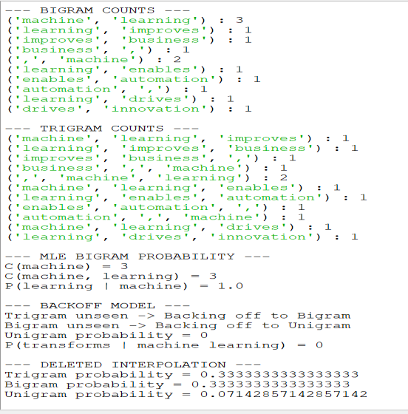
print("Predicted word:", prediction) print("\n" + "=" * 60)

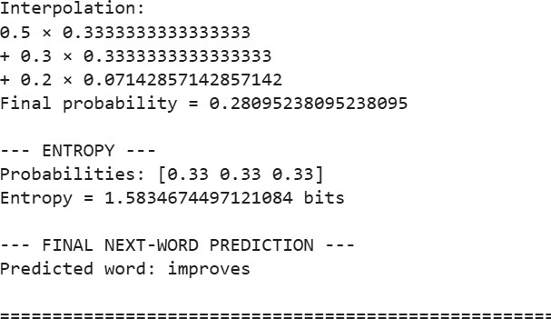
CASE STUDY 2: AI-Powered Hospital Appointment Chatbot Q1. Penn Treebank POS Tags
Sentence 1
Book an appointment with the doctor. Word POS Tag Explanation
Book VB Verb
an DT Determiner
appointment NN Noun
with IN Preposition
the DT Determiner
doctor NN Noun
. . Punctuation Therefore:
Here, Book is a verb because it represents an action:
"Book an appointment."

Sentence 2
The book contains medical information. Word POS Tag Explanation
The DT Determiner
book NN Noun
contains VBZ Verb
medical JJ Adjective
information NN Noun
. . Punctuation Therefore:
Here, book is a noun because it refers to a physical/informational object.

Q2. HMM Probability Calculation
Given:
Start probabilities: The HMM score is: For VB

For NN
Comparison:
Therefore:

Interpretation
The HMM favors VB because both:
- The start probability of VB is higher.
- The emission probability of book given VB is higher. Thus:
is greater than:

Q3. Rule-Based vs HMM POS Tagging
Feature Rule-Based POS Tagging HMM/Stochastic Tagging
Method Uses manually defined rules Uses probabilities
Context Uses grammatical rules Uses transition/emission probabilities Training Little/no statistical training Requires training data
Ambiguity Can resolve using explicit rules Resolves using probability Flexibility Less flexible More flexible
Accuracy Depends on quality of rules Depends on training corpus Healthcare chatbot Useful for known patterns Useful for varied patient language Rule-based example
If "book" occurs after "the":
book → NN and:
If "book" occurs at the beginning as an instruction: book → VB

Advantages of Rule-Based Tagging
- Easy to understand
- Easy to debug
- Works well for known grammatical patterns
- Does not require a large training corpus

Limitations
- Requires many manually written rules
- Difficult to handle unusual sentences
- Rules may conflict
- Difficult to scale

Advantages of HMM Tagging
- Handles ambiguity probabilistically
- Uses context
- Can learn patterns from data
- More suitable for varied natural language

Limitations
- Requires training data
- Probability estimates can be poor with sparse data
- May make errors on unseen patterns
For a healthcare chatbot, a hybrid approach can be useful.

Q4. Importance of Penn Treebank POS Tagset
The Penn Treebank Tagset provides standardized tags such as:
- NN → noun
- VB → verb
- VBZ → third-person singular verb
- JJ → adjective

- DT → determiner
- IN → preposition
This standardization helps downstream NLP tasks.

Intent Detection
Consider:
"Book an appointment." Book/VB indicates an action.
The chatbot can identify the intent as:
Appointment Booking

Entity Identification
For:
"appointment with the doctor"
nouns such as appointment and doctor can help identify important concepts/entities.

Response Generation
The POS structure helps the chatbot understand whether the user is:
  - requesting something
  - asking a question
  - describing something
  - providing information

Ambiguity Resolution
The same word can have different tags:
Book an appointment → Book/VB The book contains... → book/NN
Therefore, POS tagging improves contextual understanding.

Q5. Python Program – Case Study 2
import nltk

# Download required NLTK resources nltk.download('punkt') nltk.download('averaged_perceptron_tagger_eng')

#
# SENTENCES #

sentences = [
"Book an appointment with the doctor.", "The book contains medical information."
]

print("=" * 65)
print("AI HOSPITAL APPOINTMENT CHATBOT - POS TAGGING")
print("=" * 65)

#
# TOKENIZATION AND POS TAGGING #
for i, sentence in enumerate(sentences, start=1): print("\nSentence", i)
print("-" * 50)
print(sentence)

tokens = nltk.word_tokenize(sentence)

print("\nTokens:") print(tokens)
tags = nltk.pos_tag(tokens) print("\nPOS Tags:")
for word, tag in tags:
print(f"{word:15} -> {tag}")

#
# HMM CALCULATION #

print("\n" + "=" * 65)
print("HMM-BASED CALCULATION FOR 'BOOK'")
print("=" * 65)
# Given probabilities P_book_VB = 0.7
P_book_NN = 0.3

P_start_VB = 0.6
P_start_NN = 0.4 # HMM scores
score_VB = P_start_VB * P_book_VB score_NN = P_start_NN * P_book_NN

print("\nFor VB:")
print("P(Start -> VB) =", P_start_VB) print("P(book | VB) =", P_book_VB) print("Score = 0.6 × 0.7 =", score_VB)

print("\nFor NN:")
print("P(Start -> NN) =", P_start_NN) print("P(book | NN) =", P_book_NN) print("Score = 0.4 × 0.3 =", score_NN)

# Most probable tag

if score_VB > score_NN: best_tag = "VB"
else:
best_tag = "NN"

print("\n--- FINAL RESULT ---")
print("Probability for VB =", score_VB) print("Probability for NN =", score_NN) print("Most probable tag =", best_tag)

print("\n" + "=" * 65)

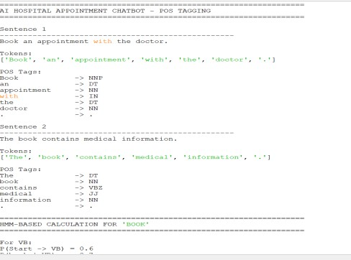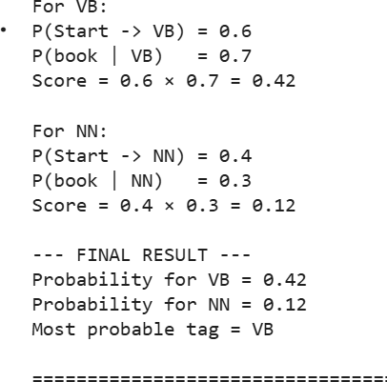

CASE STUDY 3: Financial News POS Tag Correction and Uncertainty Analysis
Sentence:

Market growth drives investment.
Initial tags:
market/NN growth/NN drives/NNS investment/NN Transformation rule:

Change NNS to VBZ if the preceding word is tagged as NN.

Q1. Apply Transformation Rule
Initial sequence:
market/NN growth/NN drives/NNS investment/NN Look at drives/NNS.
The preceding word is:
growth/NN The rule says:
NNS → VBZ
if preceding word = NN Since:
drives/NNS
preceding word = growth/NN the rule applies.
Therefore:
drives/NNS → drives/VBZ

Corrected sequence
Why is this linguistically appropriate?
The sentence is:
Market growth drives investment. The subject is:
Market growth
This is a singular noun phrase.
Therefore, the verb must be third-person singular: drives
Hence:
drives/VBZ is correct.

Q2. Why is "drives" VBZ?
The initial system incorrectly assigns: drives/NNS

NNS means plural noun. However, in:
Market growth drives investment. drives is performing an action.
It is the main verb of the sentence. The subject is:
Market growth
Since this is singular, the verb takes the third-person singular form:
drives Therefore:

Surrounding context
The grammatical structure is:
Market growth → Subject drives → Verb investment → Object Therefore:
NN + VBZ + NN
is the appropriate structure.

Q3. Relative Frequency of Each Word
Given:

Word Frequency
market 500
growth 350
drives 180
investment 420 Total frequency:
Relative frequency is:

Market Growth Drives Investment Distribution
Word | Frequency | Probability
market | 500 | 0.3448
growth | 350 | 0.2414
drives | 180 | 0.1241
investment 420 0.2897 Check:

Importance
Frequency information helps NLP systems estimate how likely a word is. A statistical POS tagger can combine:
- word frequency
- surrounding words
- transition probabilities
- emission probabilities
to select the most likely POS tag.
For example, although drives may sometimes appear as a noun, the surrounding grammatical context makes VBZ more likely here.

Q4. Entropy Before and After Transformation
The important point here is that the transformation changes the POS tag, not the word frequencies. Therefore, the given word-frequency distribution remains:

Entropy is:
Therefore:
This gives approximately:

Before transformation After transformation
Because the transformation only changes:
drives/NNS → drives/VBZ
and does not change the word-frequency counts, the word-frequency distribution remains the same. Therefore:

Important interpretation
The entropy of the word-frequency distribution does not change because the frequencies did not change. However, the tagging uncertainty is reduced because the incorrect tag NNS is corrected to the grammatically appropriate VBZ.
So:
- Word-frequency entropy → unchanged
- POS-tagging correctness → improved
- Linguistic uncertainty → reduced
This distinction is important in the exam answer.

Q5. Python Program – Case Study 3
import nltk
corrected_tags[i] = (current_word, "VBZ")

print("\n--- TRANSFORMATION RULE ---")
print("Rule: Change NNS to VBZ if preceding word is NN") print("\n--- CORRECTED POS TAGS ---")
for word, tag in corrected_tags: print(f"{word:15} -> {tag}")

#
# WORD FREQUENCIES #

frequencies = { "market": 500,
"growth": 350,
"drives": 180,
"investment": 420
}
total_frequency = sum(frequencies.values()) print("\n--- WORD FREQUENCIES ---")
print("Total frequency =", total_frequency) probabilities = {}
for word, frequency in frequencies.items():

probability = frequency / total_frequency probabilities[word] = probability

print(
f"{word:15} "

f"Frequency = {frequency:4} " f"Probability = {probability:.4f}"
)

#
# ENTROPY #

entropy_before = 0

for probability in probabilities.values():
entropy_before -= probability * math.log2(probability)

# Transformation changes POS tags only. # Word frequencies remain unchanged.

entropy_after = entropy_before print("\n--- ENTROPY ANALYSIS ---")
print(
"Entropy before transformation =", round(entropy_before, 4),
"bits"
)

print(
"Entropy after transformation =", round(entropy_after, 4),
"bits"
)

#
# FINAL RESULT #

print("\n--- FINAL POS TAGGING RESULT ---")

for word, tag in corrected_tags: print(f"{word:15} -> {tag}")

print("\n" + "=" * 70)

